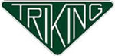 Triking Comprehensive Basic Kit - $15,199.00
Triking Type 2 Comprehensive Kit, Comprising of:
- Complete chassis with integral floor pan – powder coated finish (accepts power train from the Moto Guzzi twin shock range of bikes 850cc – 1100cc)
- Type 2 body panel set in gelcoat/primer finish (requires painting) – main bodyshell, hood and trunk, pair of mudguards, glove box and bulkhead
- Pair of Front wheels- stainless steel spokes with black rims, aluminum hub caps with Triking logo
- Grimeca Front brakes, Hydro-mechanical rear brake assembly incl parking brake (suits all std Moto Guzzi brake discs), Complete brake line set with brake light switch and stainless-steel flexible hoses
- Front suspension- wishbones, uprights, shock absorbers and all joints / bushes, Steering rack, upper and lower steering column
- Driveshaft and bearings, (non-reverse type)
- Pedal assembly, incl master cylinders
- Aluminum dashboard blank
- Push/pull type stainless steel gear linkage
- Steel fuel tank and filler cap
- Front and rear light set- headlights with integral sidelight, indicators, rear lights and reflectors
- Pair of static seat belts
- Pair of steel mudguard stays
- Stainless steel exhaust system. Headers, side pipes, expansion boxes and balance pipe (excludes silencers)
- Fully upholstered Complete vinyl Trim set, (choice of color) seats, tunnel cover, cockpit surround, side panels.
- Two cartridges of PU adhesive/sealer,
- Aluminum hood badge.
- All fixings, bearings, bushes etc. required to assemble the included components.
- All steel parts are powder coated black in color as std – other colors are available – contact us for details.
This kit is built to order – secured by a deposit and can be tailored to any bespoke individual requirements, including any combination of standard Triking parts – all aspects are compatible and interchangeable with std Triking components and upgrades. This kit option represents a practical / simplified and relatively economical starting point for customers wishing to build a std specification Triking from a kit with the addition of “donor” Moto Guzzi motorcycle,
Please note – No Moto Guzzi components are included in this kit as standard – but can be ordered separately- please contact us for further details.
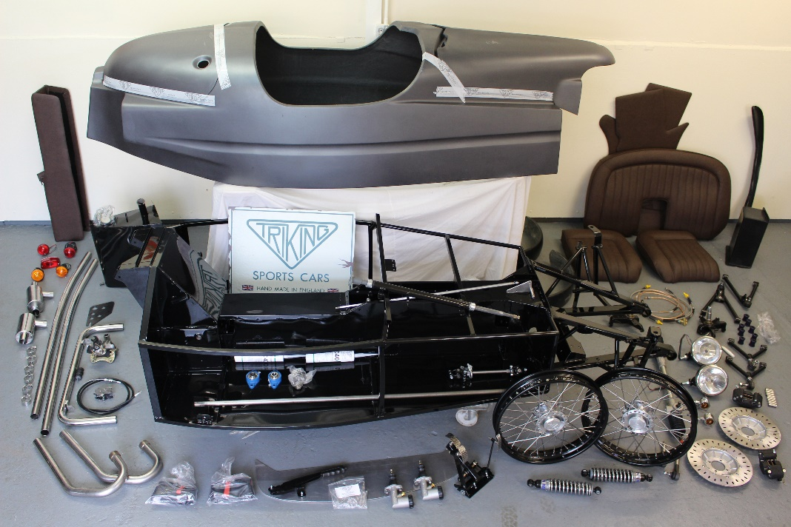Comprehensive Basic Kit
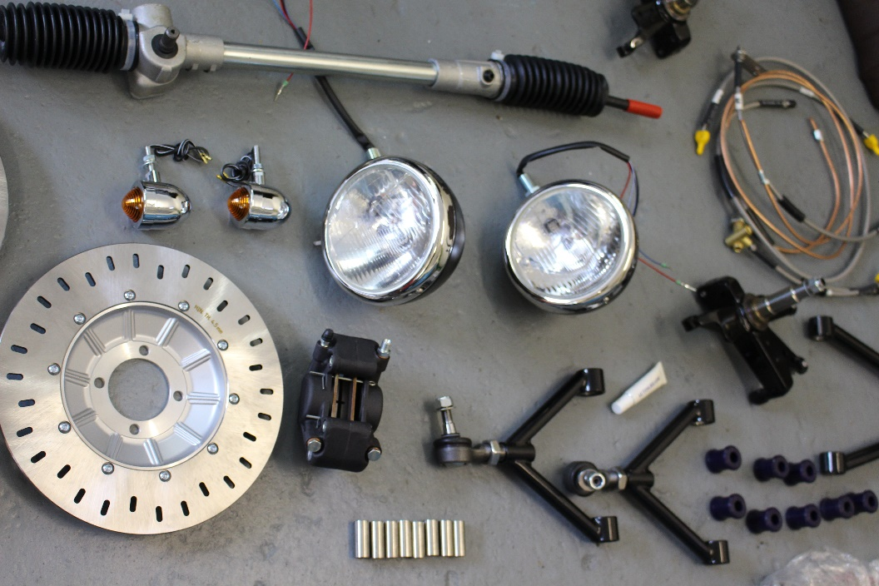
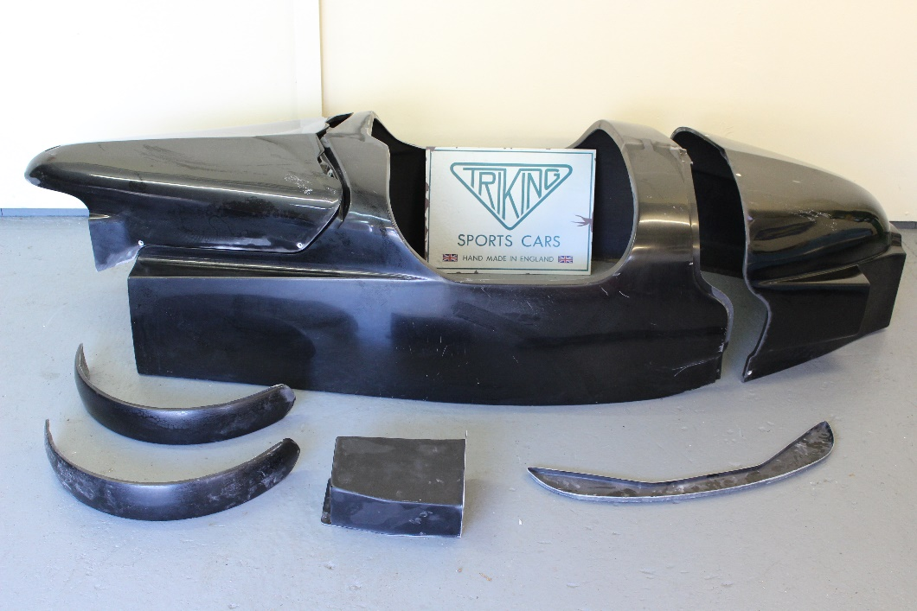Type 3 Body

